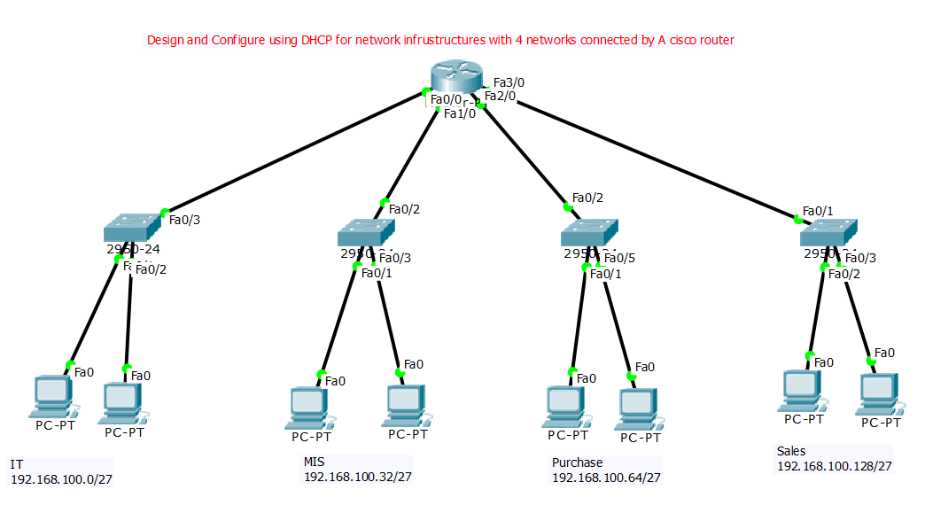

**Router**

Continue with configuration dialog? [yes/no]: no

Press RETURN to get started!

Router>en

Router#conf t

Enter configuration commands, one per line. End with CNTL/Z.

Router(config)#int fa 0/0

Router(config-if)#ip add 192.168.100.1 255.255.255.224

Router(config-if)#no shut

Router(config-if)#ex

Router(config)#int fa 1/0

Router(config-if)#ip add 192.168.100.33 255.255.255.224

Router(config-if)#no shut

Router(config-if)#ex

Router(config)#int fa 2/0

Router(config-if)#ip add 192.168.100.65 255.255.255.224

Router(config-if)#no shut

Router(config-if)#ex

Router(config)#int fa 3/0

Router(config-if)#ip add 192.168.100.129 255.255.255.224

Router(config-if)#no shut

Router(config-if)#do wr

Router(config-if)#ip dhcp pool IT

Router(dhcp-config)#network 192.168.100.0 255.255.255.224

Router(dhcp-config)#default-router 192.168.100.1

Router(dhcp-config)#do wr

Router(dhcp-config)#ex

Router(config)#ip dhcp pool MIS

Router(dhcp-config)#network 192.168.100.32 255.255.255.224

Router(dhcp-config)#default-router 192.168.100.33

Router(dhcp-config)#do wr

Router(dhcp-config)#ex

Router(config)#ip dhcp pool Purchase

Router(dhcp-config)#network 192.168.100.64 255.255.255.224

Router(dhcp-config)#default-router 192.168.100.65

Router(dhcp-config)#do wr

Router(dhcp-config)#ex

Router(config)#ip dhcp pool Sales

Router(dhcp-config)#network 192.168.100.128 255.255.255.224

Router(dhcp-config)#default-router 192.168.100.129

Router(dhcp-config)#do wr

Router(dhcp-config)#^Z

Router#wr